CouA relational database consists of a
- Collection of tables
- Heading (or definition) : table name and column names
- Body (or content part) : Rows, occurrences of data
Table Student
Column name : Table name_Column Description
Heading

Std_RollNo | Std_FName | Std_LName | Std_City | Std_State | Std_Zip | Std_Dept | Std_Year | Std_CGPA
316126510001 | Mahesh | Kumar | Hyderabad | Telangana | 500045 | IT | 2016 | 8.5
316136510008 | Vinay | Bhati | Vizag | AP | 530003 | CSE | 2016 | 7.98
315136510087 | Viraat | Sen | Vizag | AP | 530013 | CSE | 2015 | 8.9
Body
Fig 1 : The sample student table contains three sample rows, representing university students.
To understand a relational database, connections or relationships among tables must also be understood.
The rows in a table are usually related to rows in other tables matching or identical values indicate relationships between tables.
Consider the sample enrollment table, in which each row represents a student enrolled in an offering of a course.
STUDENT
Std_RollNo | Std_FName | Std_LName | Std_City | Std_State | Std_Zip | Std_Dept | Std_Year | Std_CGPA
316126510001 | Mahesh | Kumar | Hyderabad | Telangana | 500045 | IT | 2016 | 8.5
316136510008 | Vinay | Bhati | Vizag | AP | 530003 | CSE | 2016 | 7.98
315136510087 | Viraat | Sen | Vizag | AP | 530013 | CSE | 2015 | 8.9

OFFERING
Offer_No | Course_No | Offer_Term | Offer_Year | Offer_Loc | Offer_Time | Fac_No | Offer_Days
1111 | CS123 | Odd Sem | 2018 | C205 | 8:40 AM |  | MTh
1234 | CS123 | Even Sem | 2017 | C205 | 8:40 AM | 087-411 | MTh
2222 | CS123 | Even Sem | 2017 | G304 | 12:50 PM | 087-411 | TW

ENROLLMENT
Offer_No | Std_RollNo | Enr_Grade
1234 | 316126510001 | 6.8
1234 | 316136510008 | 7.6
2222 | 316126510001 | 8.9
2222 | 315136510087 | 8.1

The values in the Std_RollNo column of the enrollment table match the Std_RollNo values in the sample student table.
For example, the first and third rows, the enrollment table had the same Std_RollNo of value, 316126510001, as the first row of the student table.
Likewise, the values in the Offer_No column of the enrollment table match the Offer_No column in the offering table.
The concept of matching values is crucial in relational databases. Relational databases typically contain many tables. Large databases can have hundreds of tables.
To extract meaningful information, it is often necessary to combine multiple tables using matching values, the operation of combining tables on matching values is known as join.

Integrity Rules
Entity Integrity : Primary Keys
- Each table has column with unique values. (no tow rows of the table will have the same value)
- No missing values for primary keys
Referential Integrity : Foreign Keys
- Column values in one table must match column values in another table.
- Referential integrity ensures database contains valid connections.

Integrity Rule Violations
  Std_RollNo | Std_LName
  316126510001 | Kumar
  316136510008 | Bhati
  315136510087 | Sen
  -- | Vijay
  Offer_No | Std_RollNo
  1234 | 316126510001
  1234 | 316136510008
  2222 | 316126510001
  2222 | 315136510087
  4321 | 316136510008
  4321 | --
Offer_No | Course_No
1111 | CS123
1234 | CS123

In this example, missing values are shown by hyphens.
Fourth row of the student table has a missing value. The missing value is known as a null value.
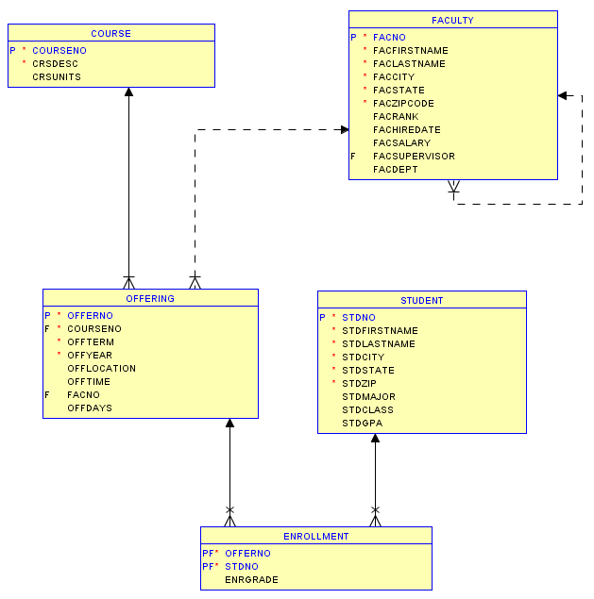
The Oracle relational diagram shows the tables in relationships of the university database. In previous examples we have seen the student, offering and enrollment tables. This diagram adds two new tables, course and faculty to note in courses in the university catalog and faculty who work at the university.

Notation
The primary key of the table is marked with a P. For example, course number is the primary key of the course table.
Foreign keys are marked with the FK abbreviation. For example, the offering table has two foreign keys. Course number referencing a course table and fact number referencing a faculty table.
The lines represent relationships with referential integrity constraints.
Each relationship has a parent table appearing next to the arrow in the line and a child table appearing next to the foot symbol. For example, the line between course and offering means that a relationship exists from course to offering with course as the parent table and offering as the child table. This relationship means that a course can be related to many offerings. Therefore, we can say that there is a one to many relationship.
A solid line means that the foreign key cannot have missing values. For example, the values in course number column of the offering table cannot have missing or null values, because the relationship line is solid in the diagram.
A dashed line in the diagram means that the foreign key can accept missing or null values. For example, fact number foreign key in the offering table can accept null values is the faculty for an offering may not be assigned until after the offering is initially entered into the database.
The PF abbreviation, indicates that the column is both part of the primary key and the foreign key. For example, offer number and student number in the enrollment table are both components of the primary key. The primary key is a combination of both columns. In addition, they are both foreign keys to the offering and student tables respectively.
A database diagram is essential for understanding the major components, primary keys, foreign keys and relationships of a database and formulating queries that combine tables.

LAB OBJECTIVES
Date: 27/06/2018 & 29/06/2018
- Write CREATE TABLE statements with column specification including data types.
- Read CREATE TABLE statements to see columns and associated data types.
- Read and Write CREATE TABLE statements with PK Constraints.
- Read and Write CREATE TABLE statements with FK Constraints.
- Read and Write CREATE TABLE statements with CHECK Constraints.

CREATE Table syntax
- CREATE TABLE <table_name> (<column-list> [<constraint-list>])
- Column list with data types and optional and inline constraints.
- Optional external constraint list
  - CONSTRAINT [Constraint name] <Constraint-spec>
  - Primary Key
  - Foreign Key
  - Unique
  - Check
CREATE TABLE STUDENT
(
Std_RollNo Char(11),
Std_FName VARCHAR(50),
Std_LName VARCHAR(50),
Std_City VARCHAR(50),
Std_State CHAR(20),
Std_Zip CHAR(10),
Std_Dept CHAR(4),
Std_Year CHAR(4),
Std_CGPA Decimal(3,2)
);

Common Syntax errors
- Keywords must be spelled exactly
- Database compilers do not have spell correction.
- Each column definition is terminated by a comma. A missing comma will result in a syntax error.
- Entire statement terminates with a right parenthesis.
Common SQL Data types
- CHAR(L) - Fixed length character string or text-L indicates max length. (use for columns with values of same lenth)
- VARCHAR(L) – Variable length character string. L indicates max length.
- INTEGER – Whole number and not numbers with decimal points.
- FLOAT(P) - numbers with floating precision. P indicates number of digits after decimal.
- DECIMAL(W,R) – Number with fixed precision. W indicates total no. of digits, R indicates total no. of digits to the right of the decimal point.
- DATE/TIME : DATE, TIME, TIMESTAMP
CREATE TABLE statements with integrity constraints
The create table statement allows 5 different subjects in constraints.

SUBJECT | Primary Key
SUBJECT | Foreign Key
SUBJECT | UNIQUE
SUBJECT | REQUIRED (Not Null)
SUBJECT | CHECK
PLACEMENT | INLINE
PLACEMENT | EXTERNAL

CONSTRAINT Syntax Examples – Naming conventions. Why are constraint names important ?

- CONSTRAINT PKCourse PRIMARY KEY(Course_No)
- CONSTRAINT PKEnrollment PRIMARY KEY (Offer_No, Std_RollNo)
- CONSTRAINT UniqueCrsDesc UNIQUE (CrsDesc)
- CONSTRAINT FKOfferNo FOREIGN KEY (Offer_No) REFERENCES Offering
- CONSTRAINT OffCourseNoReq NOT NULL
When the Primary Key is a combination of two columns (as shown in example 2), it must be placed external only.
Required constraints are generally specified inline.
Constraint name is optional but good practice to identify the error when a constraint violation occurs.
The keyword CONSTRAINT is optional for inline constraints but required for external constraints/
- Write a CREATE TABLE statement for the Student table. Choose data types appropriate for the DBMS. All columns are required (not null).
- Write a CREATE TABLE statement for the Faculty table. Choose data types appropriate for the DBMS. All columns are required (not null).
- Write a CREATE TABLE statement for the Course table. Choose data types appropriate for the DBMS. All columns are required (not null).
- Write a CREATE TABLE statement for the Offering table. Choose data types appropriate for the DBMS. All columns are required (not null).
- Write a CREATE TABLE statement for the Enrollment table. Choose data types appropriate for the DBMS. All columns are required (not null).
- Identify the 1-M relationship(s) among the tables. For each relationship, identify the parent table and the child table.
- Extend your CREATE TABLE statements with referential integrity constraints.
- Extend your CREATE TABLE statements with UNIQUE constraints wherever you think necessary.
- Write down the difference between PRIMARY KEY and UNIQUE Constraints.
- Write down the table descriptions of all tables created.
For eg
